**DigitRati React Training -Assessment**

Project Approach:

Manager Home: Getting the Employee Data for the Table

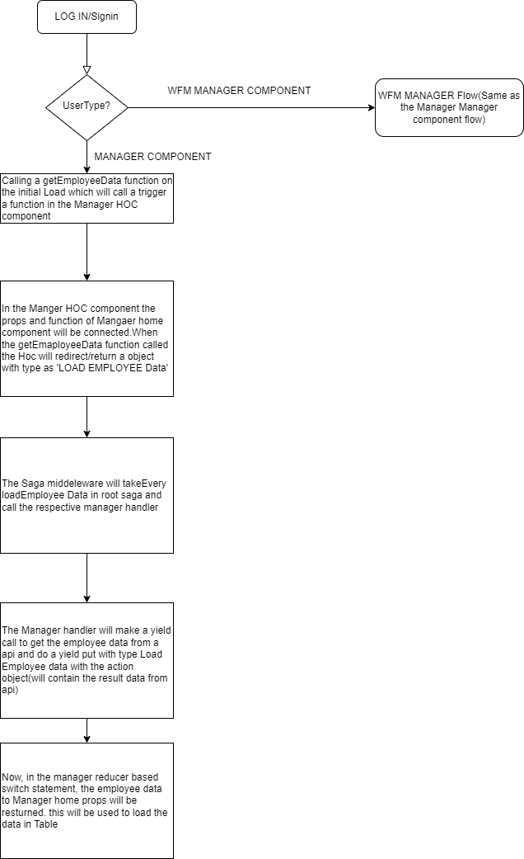

Manager : Send the Request to the WFM Manger in the Popup.

